1. **For fitting a neural network model to predict the price, what variables will you use?  Explain why you included or excluded each potential predictor.**

**Variable selection using Decision Trees:**

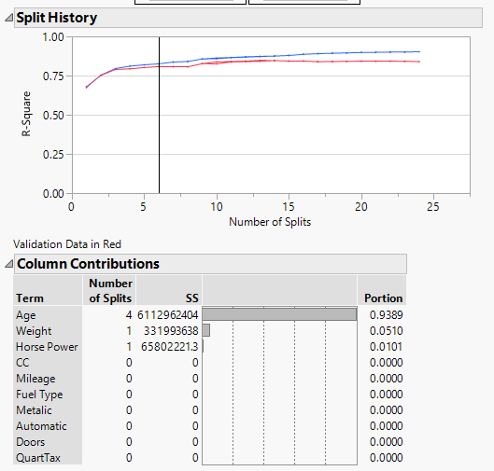

From the above graph, at split = 6, factor variables into the neural network models.

Therefore Horse Power, Age and Weight are the predictors I used for my neural net model.

1. **Build an initial neural net model to predict price.  Include a screen shot of your initial choices for model input.  What is the model's RMSE?  Save your predictions and residuals to the data table.**

**The initial choices for model input are:**

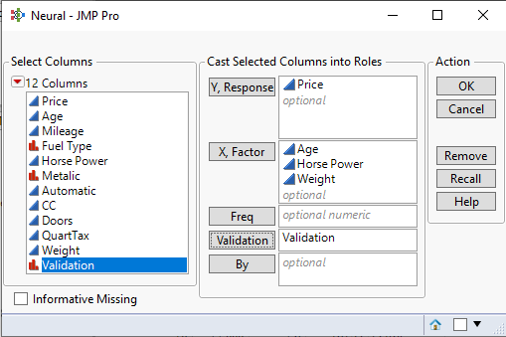

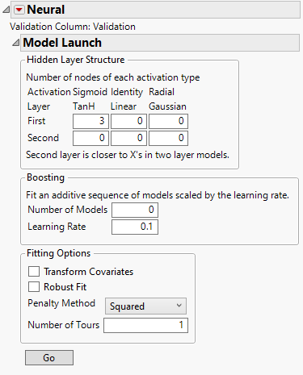

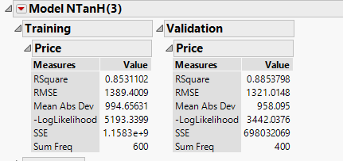

**RMSE for above inputs is 1321.**

**Screenshot of Residuals:**

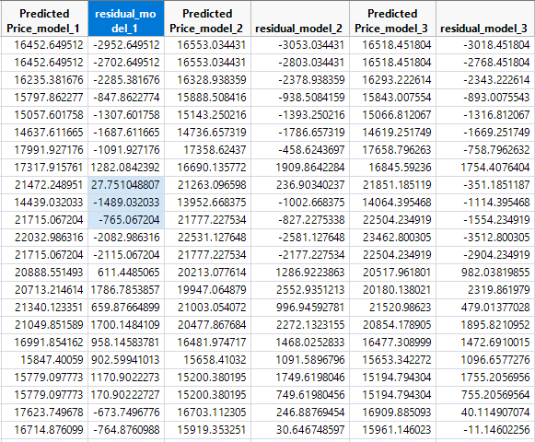

1. **Build another neural net model to predict price.  Include a screen shot of your choices for model input.  What did you change and why?  What is the model's RMSE?  Save your predictions and residuals to the data table.**

The input layer values have been changed. I have allocated the three nodes 1,2 and 3 with TanH, Linear and Gaussian functions respectively in order to tune the model and compare accuracy of the model.

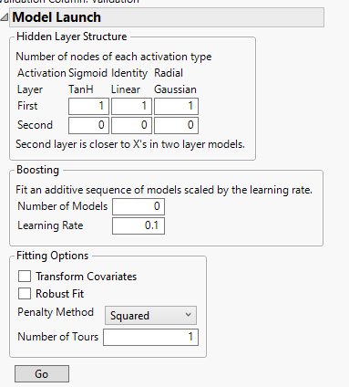

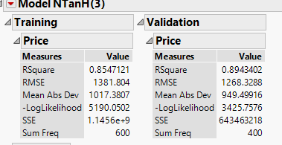

**RMSE for this model is 1268.3**

**4.  Build a third neural net model to predict price.  Include a screen shot of your choices for model input.  What did you change and why?  What is the model's RMSE?  Save your predictions and residuals to the data table.**

In my third neutral net model, I have introduced a second layer to include TanH function for all three nodes.

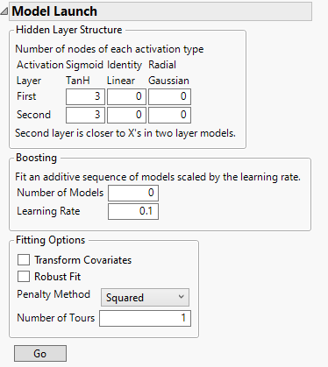

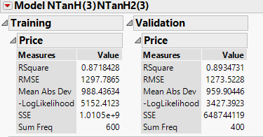

**The third model’s RMSE is 1273.5.**

**5.  Create a histogram, boxplot, and summary statistics for the 3 model residuals and include screen shots of each.  What is the average error for each model?**

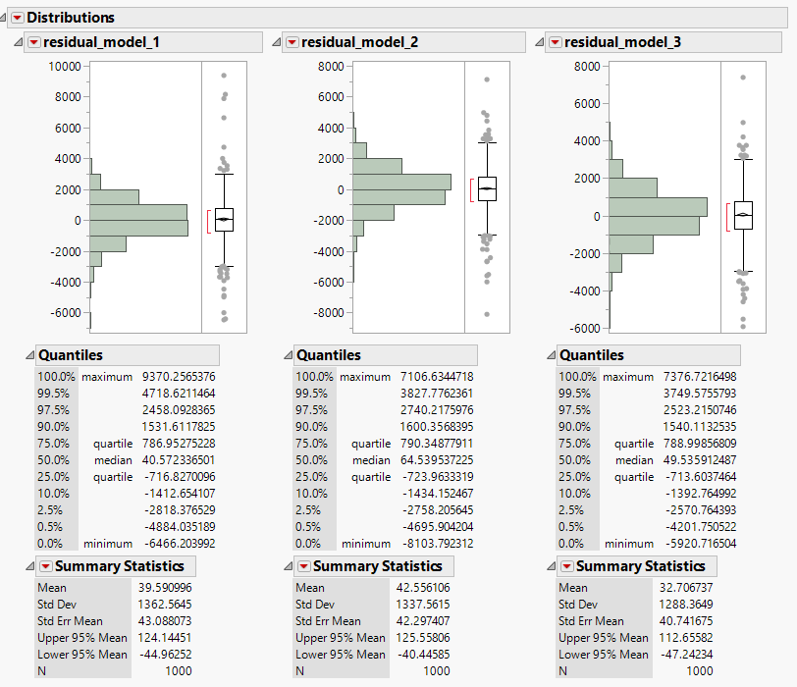

The residual column = Values in (**Actual – Predicted**)

Average error for Model in Q2 is **39.5**

Average error for model Q3 is **42.556**

Average error for model Q4 is **32.7**

**6.  Which model would you choose as the best and why?**

I would choose the model I created in Q4 as it has an average mean error (32.7) which is significantly lower than models in Q2 and Q3, a lower error is always preferable. It can also be noted that the RMSE value (1268.3) is the least for Q3 and is also qualifies for being an equally best model.